Procedure for upgrade Xpress from version 1.2 to 1.3

Download the upgrade file at this link (section “Downloads” – “Softwares & Upgrades” of www.lovatoelectric.com)

- Unzip the file and launch “Updater.exe” as administrator
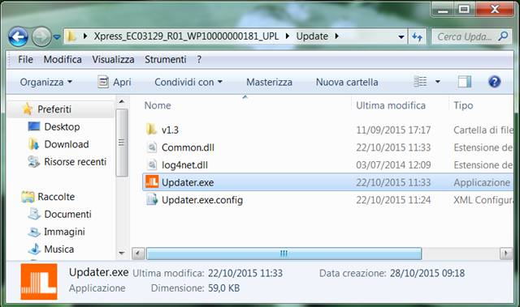

- Click “OK” and wait until the following message appears: